Table of Contents

1 Table of Figures 1

2 Table of Tables 1

3 Table of Equations 1

4 Subsystem Four: Communications 2

4.1 Requirements and Functional Decomposition 2

4.2 Background and Prior Art 3

4.3 Approach and Execution 4

4.4 Results and Discussion 6

5 Bibliography 8

# Table of Figures

Figure 34: SS4 Breakdown 2

Figure 35: Packet Protocol 5

# Table of Tables

Table 6: UART Pins 4

Table 7: UART Configuration 4

Table 8: DMA Configuration 4

Table 9: Packet Protocol 5

# Table of Equations

No table of figures entries found.

# Subsystem Four: Communications

This section details the analysis, design, implementation, and results of the subsystem responsible for communication between the actuation systems and the controls/perception systems.

## Requirements and Functional Decomposition

The overarching purpose of subsystem four (SS4) is to communicate the desired action to the actuation system.

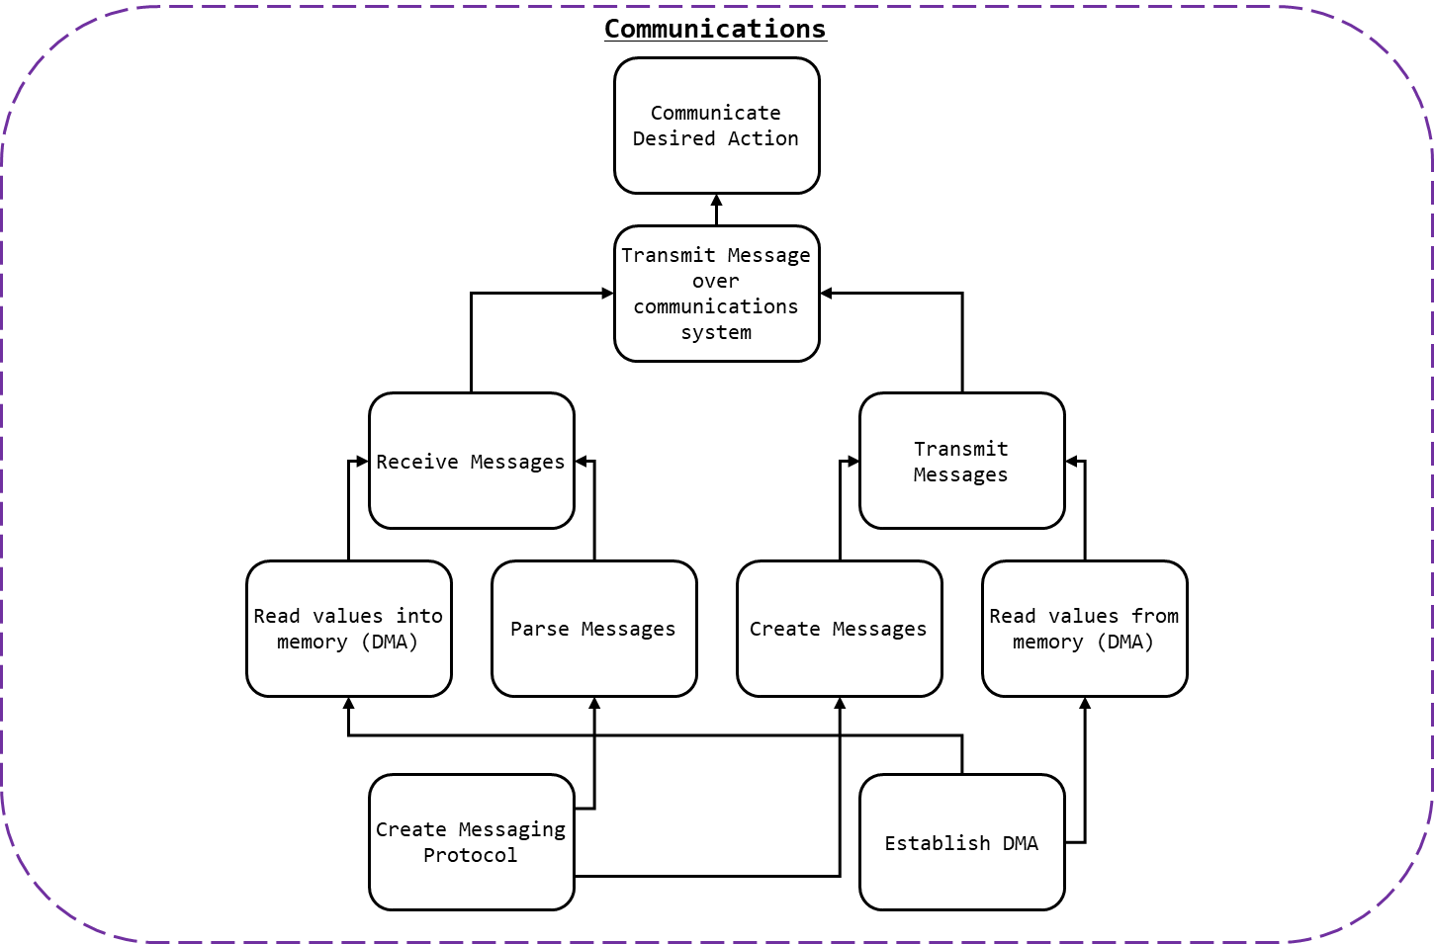

Figure 1: SS4 Breakdown

As detailed in Figure 1: SS4 Breakdown, to communicate the desired action to the actuation system:

* Messages would need to be received; and,
  + This process would involve receiving the messages; and,
  + Parsing them into useable data.
* Messages would need to be sent.
  + This process should involve creating messages; and,
  + Transmitting them.

To ensure that messages where properly interpreted and created by all parties a communication protocol and packet protocol would be need.

To store messages, received or sent, numerous methods were considered and tested. Ultimately, Direct Memory Access (DMA) was used which required that the DMA on the selected microcontroller be enabled.

### Communication Protocol

The requirements of the communication protocol where as follows:

* ASCII messages must be transmittable;
* Synchronisation or dependency between systems is to be avoided;
* Systems which required addresses for communication were to be excluded.

### Packet Protocol

The requirements of the packet protocol where as follows:

* Generic data types must be transmittable;
* Signed values (plus/minus) of either integers or real numbers would be sent; and,
* Start and stop bits characters would be used to indicate the beginning and the end of messages (in the case of incomplete messages, the message should be invalid).

### Connection Method

The requirements of the connection where as follows:

* Wired connection method;
* A common ground should be established (where relevant); and,
* Where possible standardised jacks/sockets should be used.

## Background and Prior Art

Parallel communication is the method of communicating a multibit message over multiple channels. With enough channels, parallel communication may be used to communicate a message of *any* size in a single clock cycle. However, communication channels can be resource intensive (i.e. using lots of cables and pins, the physical size of the interconnect).

Instead serial communication involves sending data over a single channel sequentially. While often slower than parallel communication, serial communication is often preferable due to the scarcity of I/O lines on microcontrollers. A protocol of encoding messages is used to transmit messages in a consistent intelligible manner.

Serial communication may be synchronous or asynchronous. Synchronous uses a clock signal to synchronise communication. This can result in faster more reliable communication but depends on a centralised clock signal; to maximise demarcation between the project sections, synchronous communication shall not be used.

Asynchronous serial communication may be accomplished by the use of a pair of wires (one for transmission, one for receiving) and by transmitting messages in binary. Messages which can be encoded in binary (e.g. ASCII) may be transmitted in this manner.

A universal asynchronous receiver-transmitter (UART) is a hardware device for asynchronous serial communication that may be integrated into a microcontroller. UART may be used to implement asynchronous serial communication on a microcontroller via I/O lines.

Direct memory access (DMA) is a mechanism by which hardware systems (like UART) are able, independent of the central processing unit (CPU), to interface directly with the main system memory. By bypassing the CPU read and write operations can be completed faster, while the CPU is dedicated to other tasks. For example, messages received via UART may be directly stored in memory, and messages to be sent via UART may be loaded into buffers directly.

## Approach and Execution

### Communication Protocol

For details relating to the microcontroller selection see section (kt). As noted in section kt, two communication channels were required per microcontroller.

Two UART channels where implemented in C for the STM32 Nucleo boards. The pin used by each channel is shown in Table 1: UART Pins.

Table 1: UART Pins

|  |  |  |  |  |
| --- | --- | --- | --- | --- |
| UART | Function | STM32F303k8 Pin | Nucleo Connector Pin | DMA Channel |
| UART 1 | RX | Port A Pin 10 | D0 | 5 |
| TX | Port A Pin 9 | D1 | 4 |
| UART 2 | RX | Port A Pin 3 | A2 | 7 |
| TX | Port A Pin 2 | A7 | 6 |

Much of the peripheral initilisation was completed used STM32CubeMX. The configuration file used can be found in kt. The configuration of both UART channels may be found in Table 2: UART Configuration.

Table 2: UART Configuration

|  |  |
| --- | --- |
| Parameter | Value |
| Baud Rate | 9600 Bits/s |
| Word Length | 8 Bits (Including Parity) |
| Parity | None |
| Stop Bits | 1 |
| Alternate Function (for GPIO) | 7 |

Each UART was configured to use DMA to receive and transmit messages. The DMA settings can be found in Table 3: DMA Configuration.

Table 3: DMA Configuration

|  |  |
| --- | --- |
| Parameter | Value |
| DMA Mode | Normal (Not circular) |
| Data Width (Peripheral) | Byte |
| Data Width (Memory) | Byte |
| Increment Address | Memory |
| Priority | Medium |

The process of transmitting a message was as follows:

* Ensure UART 1 and 2 were ready for transmission;
  + Via isTransmitting, which may be found in /Src/main.c
* Load message into buffer; and,
* Direct UART to transmit buffer via DMA.
  + Via HAL_UART_Transmit_DMA, which may be found in /Drivers/STM32F3xx_HAL_Driver/Src/stm32f3xx_hal_uart.c

### Packet Protocol

As seen in Figure 2: Packet Protocol, a packet protocol was established to ensure that messages could be understood.

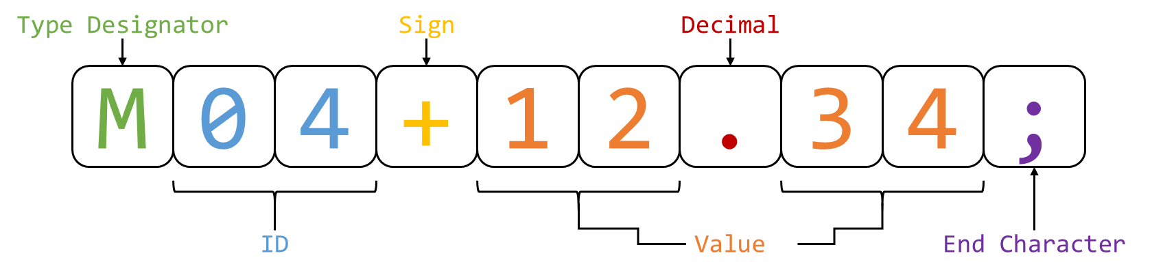

Figure 2: Packet Protocol

The protocol is detailed in Table 4: Packet Protocol:

Table 4: Packet Protocol

|  |  |
| --- | --- |
| Value | Notes |
| Type Designator | The non-case-sensitive type designator indicated what type of value was being transmitted. For example, ‘T’ (or ‘t’) indicated that the value represented the desired torque of an actuator. Size: 1 char |
| ID | The integer representing which value of a given type was being updated. For example, an ID of 03 referred to the right foot. Size: 2 chars |
| Sign | Used to indicate if the value was positive or negative. Size: 1 char |
| Value | The value being updated. This could be of any length. A left-hand side and right-hand side value (even if 0) was required for a valid message (e.g. 11 or .5 was invalid, but 11.0 and 0.5 was valid. |
| Decimal | Used to punctuate the value received. Indicated the end of the left-hand side of the value. Size: 1 char |
| End Character | Used to indicate the end of a message. Upon reading a valid message this value would be changed to an ‘@’ to prevent the same message (within the DMA buffer) from being ready twice. Size: 1 char |

This protocol was used for all communicates to, from, and within the controls/perception system.

### Connection Method

As UART was to be used over a two-wire connection three wires in total were required:

* RX;
* TX; and,
* Ground.

A common ground ensures that all RX an TX messages where read correctly and had the same reference voltage. While numerous cable options where viable, Category 5 cable, or CAT 5, cables where selected to connect devices together.

CAT 5 cables are twisted pair cables (4 sets) commonly used in ethernet connection. CAT 5 cable were terminated with 8P8C modular connectors and plugged into female RJ45 connectors. As CAT 5 cables feature more than three wires it became possible to provide 5V across boards, this is discussed in further detail in kt. These connectors were then mounted on the controller PCB, see kt.

## Results and Discussion

SS4 was tested by daisy chaining multiple controller boards together via 1.5m CAT 5e cables. Each board would transmit the messages relevant to it on both UART 1 and UART 2. Messages received would be parse. Invalid messages were discarded. Valid messages where then passed along the chain to ensure all controller boards were informed, e.g. valid messages incoming to UART 1 were sent outgoing to UART 2.

For the thesis demonstration, two boards where connected and sensor readings from one board were used to communicate actuator commands to the other.

In both these test case the communication system was perfectly functioning. Messages were sent and transfer, no corrupt messages were interpreted as valid, and messages where interpreted correctly.

The interface between the actuation system and the controls/perception system was never completed. Provisions were made for connection to another system (these were also used for debugging), see kt, but were tested as the actuation system was never completed. While one can be confident that the communication system would function as required, it cannot be said for certain without testing.

### Communication speed

It is difficult to say if the communication system would have been fast enough to allow for real time control of the system. While messages were kept short and DMA was employed to speed messaging the baud rate of 9600 may have been simply too low for the communication speeds required.

Given an 8-bit char (ASCII character) approximately 109 messages (of standard size) could be sent per second, or about 9ms per message. Given the potential for a message to be passed on up to 6 times before being interpreted by the actuation system, and that up to 5 messages may be queued to be sent by each controller, a maximum delay of 192ms (21 message periods) could be expected. Given a human reaction time of 150 – 300ms (Yuhas, 2012), a system with a reaction time of 192ms will lag behind the user and not react sufficiently quickly.

Going forward it is recommended that the baud rate of the system is raised to 115200 bits/s. Transmitting messages twelve times faster will result in a reaction time of 16ms and reduce the possibility of lag.

# Bibliography

Agarwal, A. (2005). *Foundations of analog & digital electronic circuits* (1 ed.). Massachusetts: Massachusetts Institute of Technology. Retrieved June 1, 2018, from https://www.google.com/url?sa=t&rct=j&q=&esrc=s&source=web&cd=1&ved=0ahUKEwiBu7yQl7LbAhUEoZQKHfYlBzkQFggpMAA&url=http%3A%2F%2Fsiva.bgk.uni-obuda.hu%2Fjegyzetek%2FMechatronikai_alapismeretek%2FEnglish_Mechatr%2FElectr_Eng-1%2FLiterature%2FFoundations%2520o

American Technologies Network Corporation. (2018, May 30). *How Does Night Vision Work*. Retrieved from atncorp.com: https://www.atncorp.com/hownightvisionworks

Arrow. (2018). *Magnetoresistive Sensor.* Retrieved May 30, 2018, from arrow.com: https://www.arrow.com/en/categories/sensors/magnetoresistive-sensors

Axe, D. (2012, May 23). *Combat Exoskeleton Marches Toward Afghanistan Deployment*. Retrieved May 30, 2018, from Wired: https://www.wired.com/2012/05/combat-exoskeleton-afghanistan/

Bulgrin, M. (2017, May 11). *The History of the Hose Clamp.* Retrieved from normagroup.com: https://blog.normagroup.com/en/the-history-of-the-hose-clamp/

Bunnings. (2018, May 31). *Kinetic 21 - 44mm 304 Stainless Steel Hose Clamp.* Retrieved May 31, 2018, from Bunnings.com: https://www.bunnings.com.au/kinetic-21-44mm-304-stainless-steel-hose-clamp_p4920194

Charara, S. (2015, July 9). *This robotic exoskeleton helps paralysed patients to walk and it's getting smarter*. Retrieved August 23, 2017, from Wearable: https://www.wareable.com/wearable-tech/exoskeleton-paralysed-patients-ekso-bionics-gt-sarah-thomas

Computer Cable Store. (2018, May 31). *11 7/8 Inch Black Standard Nylon Cable Tie - 100 Pack.* Retrieved May 31, 2018, from computercablestore.com: https://www.computercablestore.com/11-78-inch-black-standard-nylon-cable-tie-100-pack

Cornwall, W. (2015, October 15). *Feature: Can we build an ‘Iron Man’ suit that gives soldiers a robotic boost?* Retrieved August 20, 2017, from sciencemag.org: http://www.sciencemag.org/news/2015/10/feature-can-we-build-iron-man-suit-gives-soldiers-robotic-boost

Cracknell, A. P., & Hayes, L. (2007). *Introduction to Remote Sensing* (2 ed.). London: Taylor and Francis. Retrieved May 30, 2018

Cutnell, J. D., & Johnson, K. W. (1998). *Physics* (4th ed.). New York: Wiley.

Cyberdyne. (2015, August 1). *CYBERDYNE Inc. has begun seeking approval from the U. S. Food and Drug Administration (FDA)*. Retrieved August 23, 2017, from cyberdyne.jp: https://www.cyberdyne.jp/english/company/PressReleases_detail.html?id=1075

Cyberdyne. (2016). *What’s HAL?* Retrieved August 19, 2017, from cyberdyne.jp: https://www.cyberdyne.jp/english/products/HAL/

Cybernetic Zoo. (2010, October 14). *1890 – Assisted-walking Device – Nicholas Yagn (Russian)*. Retrieved May 30, 2018, from Cyberneticzoo.com: http://cyberneticzoo.com/tag/nicholas-yagn/

Cybernetic Zoo. (2010, April 10). *1965-71 – G.E. Hardiman I Exoskeleton – Ralph Mosher (American)*. Retrieved May 30, 2018, from cyberneticzoo.com: http://cyberneticzoo.com/man-amplifiers/1966-69-g-e-hardiman-i-ralph-mosher-american/

Dawkins, P. (2018). *Differential Equations - Notes - Laplace’s Equation*. Retrieved June 3, 2018, from Paul's Online Math Notes: http://tutorial.math.lamar.edu/Classes/DE/LaplacesEqn.aspx

Dunietz, J. (2017, July 27). *Robotic Exoskeleton Adapts While It’s Worn*. Retrieved August 20, 2017, from scientificamerican.com: https://www.scientificamerican.com/article/robotic-exoskeleton-ldquo-evolves-rdquo-while-its-worn/

Future Electronics. (2018, May 30). *What is Optoelectronics?* Retrieved from Future Electronics: http://www.futureelectronics.com/en/optoelectronics/infrared-receivers.aspx

Garbett, I. (2001, Janurary 1). *Light attenuation and exponential laws*. Retrieved May 30, 2018, from plus.maths.org: https://plus.maths.org/content/light-attenuation-and-exponential-laws

Golnaraghi, F., & Kuo, B. C. (2010). *Automatic Control Systems* (9 ed.). Hoboken: John Wiley & Sons, Inc. Retrieved June 4, 2018

Gross, K. (2018, Feburary 19). *Ultrasonic Sensors: Advantages and Limitations*. Retrieved May 30, 2018, from MaxBotix: https://www.maxbotix.com/articles/advantages-limitations-ultrasonic-sensors.htm/

Jackson, R., Green, K. R., & Eisenbeis, R. (2017). *Achieve greater precision, reliability with integrated magnetic sensing technology.* Retrieved May 30, 2018, from ti.com: http://www.ti.com/general/docs/lit/getliterature.tsp?baseLiteratureNumber=sszy030&fileType=pdf

Karlin, S. (2011, July 29). *Raytheon Sarcos’s Exoskeleton Nears Production*. Retrieved August 11, 2017, from spectrum.ieee.org: http://spectrum.ieee.org/at-work/innovation/raytheon-sarcoss-exoskeleton-nears-produc

Keller, M. (2016, August 25). *Exoskeleton - Do You Even Lift, Bro? Hardiman Was GE’s Muscular Take On The Human-Machine Interface*. (General Electric) Retrieved May 30, 2018, from GE Reports: https://www.ge.com/reports/do-you-even-lift-bro-hardiman-and-the-human-machine-interface/

Keyence Corporation. (2018). *What is a Inductive Proximity Sensor?* Retrieved May 30, 2018, from keyence.com: https://www.keyence.com/ss/products/sensor/sensorbasics/proximity/info/

Khatib, O. (2008). Chapter 5 - Dynamics. In O. Khatib, *Introduction to Robotics* (pp. 125-150). Stanford: Stanford University.

Liew, S. C. (2018, May 30). *Electromagnetic Waves*. Retrieved from Centre for Remote Imaging, Sensing and Processing.: https://crisp.nus.edu.sg/~research/tutorial/em.htm

Lynch, D. K., & Livingston, W. C. (2001). *Color and Light in Nature* (2nd ed.). Cambridge, United Kingdom: Cambridge University Press. Retrieved May 30, 2018, from https://books.google.com.au/books?id=4Abp5FdhskAC&pg=PA231&redir_esc=y#v=onepage&q&f=false

Merriam-Webster Dictionary. (2018, May 18). *noise*. Retrieved May 30, 2018, from merriam-webster.com: https://www.merriam-webster.com/dictionary/noise

National Instruments. (2018). *PID Theory Explained.* Retrieved June 4, 2018, from NationalInstruments.com: http://www.ni.com/white-paper/3782/en/

Ogata, K. (2010). *Modern Control Engineering* (2 ed.). New Jersey, United States of America: Prentice Hall. Retrieved August 25, 2017

Otaga, K. (2004). *System Dynamics* (4 ed.). Upper Saddle River: Pearson. Retrieved June 4, 2018

Robomart. (2015, November 9). *Advantages and Disadvantages of ultrasonic distance sensor.* Retrieved May 30, 2018, from Robomart: http://roboticsensors.blogspot.com/2015/11/advantages-and-disadvantages-of.html

Siciliano, B., & Khatib, O. (2016). *Springer Handbook of Robotics* (2 ed.). (B. Siciliano, & O. Khatib, Eds.) Berlin: Springer Nature. doi:10.1007/978-3-319-32552-1

Texas Instruments Incorporated. (2017). *Hall effect sensors*. Retrieved May 30, 2018, from ti.com: http://www.ti.com/sensing-products/magnetic-sensors/hall-effect/overview.html

Thomas Publishing Company. (2018). *Capacitive Proximity Sensors*. Retrieved May 30, 2018, from Thomas: https://www.thomasnet.com/articles/instruments-controls/proximity-sensors

Vishay Semiconductors. (2017, February 8). TCRT5000 - Reflective Optical Sensor with Transistor Output.

Yagin, N. (1890, February 11). *United States of America Patent No. 440684.*

Yuhas, D. (2012, May 24). *Speedy Science: How Fast Can You React?* Retrieved from scientificamerican.com: https://www.scientificamerican.com/article/bring-science-home-reaction-time/

ZJIA. (2018, June 1). *Generic YZC-161B 50kg Body Scale Sensor Human Scale Weighing Load Cell Sensor (Pack of 4)* . Retrieved June 1, 2018, from Amazon.com: https://www.amazon.com/Generic-YZC-161B-Scale-Sensor-Weighing/dp/B00MTJ6WZ2